Basic definition
The Contingency Theory of Leadership states that a leader’s effectiveness is contingent upon with how his or her leadership style matches to the situation. Leader match theories
That is, the leader must find out what kind of leadership style and situation he or she thrives in.

Theory based

This theory was based on the behavioral theory and the style approach of the leader, the theory describes what leader do in different situations, leadership type were categorized according to the combine level of task oriented and relationship oriented

Leaders behavior in decision-making may be directive, persuasive and participation (in the decision-making process)
The overall structure might be initiating structure (orient and maintain the team) consideration (considerate for it employs self-esteem, equal treat and open to criticism)
However, this theory does not concern with the effectiveness of the leaders

Principles
Contingency add on the leadership behavior as a mediator to between effectiveness and leadership
The principle for contingency are:
Substitute for leadership: Directly affect the employee’s outcomes and replace the need for the leader
E.g. self-leadership, able to self- goal setting, redesign the meaning of work
neutralizers of leadership: Inhibit the effect of the leader’s influence on the outcome, the attribute that make leader impossible to make any different to the out come
the follower just doesn’t like the leader and think he/she is bad

- Fiedler’s contingency theory
- developed by Fred Fiedler in 1958 during his research of leader effectiveness in group situations, depend on how well the leader match the situation
- one of the first comprehensive contingency model
- his research found the good and bad leadership styles that fit the organizational context, and there is not a best way to lead the team
- the leadership styles are fix, they have to find the best situation for them to lead
leadership styles
- the scale develops by fielder to test the leadership style
it asks leader to think the people they work at least well and according to the criticalness the score of LPC will be high or low
- describe as task motives or relationship motives, the higher the LPC score the more relationship oriented they are
- task oriented leader concerned primary with reaching the goals
Define and structure work roles and goals, clarify procedures, monitor performance
- relationship oriented leader concerned with developing close relationship
Mutual trust & respect, genuine concern, support

Situational variable
- the effectiveness of the LPC score and efficiency depend on the complex situational variables called favorability (situational control), weather the situation give leaders control over the subordinates
- leader-member relationship
the extend to subordinate loyalty
friendly and corporative relationship with them
- position power
the extent of leader has authorities to evaluate subordinate performance, administrate reward and punishment
- task structure
extent to standard operating procedure to accomplish the task
detail description of the final product or service and objective indication of how well the task is being performance
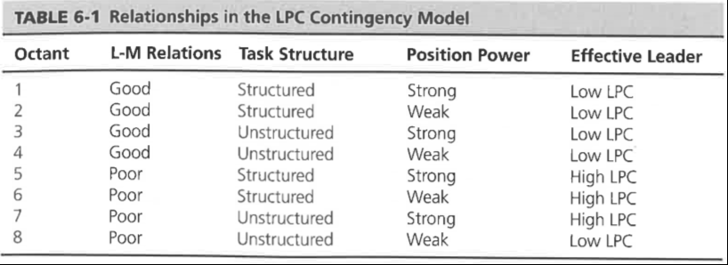

- When leader worker relation is good, worker are more likely to comply with leader require
- The least favorable situation for the leader is poor L-M performance, unstructured task and weak power position
- The situational fact act as an meditator to add on the efficiency and leadership style

研究
- 研究没能够完全证明每一个组合的有效性
- 没能够在数据上足够的支持，这个权重是故意为这个模型的有效性而建的
弊端
- Conceptual weakness measure in the search of mean 故意为了要这个模型
- LPC 表是主观的，不一定能让你很好的评估自身的领导风格， 而且过于两端性了
- 没有解释为什么不同的组合会导致有效
- 理论的中心基于性格框架理论，这里假设领导人的风格是不会变的，但又未必
- 并不是一个很好的领导选拔机制
- 这个理论的最终是领导要通过改变这一些环境因素来让他达到更好得效用，但是有些改变并不是很好的

- Path goals theory

- Develop to explain how the behavior and motivation function of leader influence subordinate satisfaction and performance
- Theoretic based
Based on the expectancy theory: work motivation in term of choice of process, determine by the expectation to the act according to given outcome and the attractiveness of outcome to individual and the leader behavior are at the initial to modify the belief and perception that build expectation (expectation x implementing x valence)

- Leadership styles
Supportive leadership支持型，给员工的状态以及在工作上提供帮助,
directive leadership 指令型，告诉下属如何去做，怎么做，期待的成果是什么 participative leadership 参与型，支持员工的参与，开放式，舒服的气氛
achievement-oriented leadership, 成就型，给员工制定有挑战的目标，push them up and shown the confidence and ambition that they are going to achieve the aim
task orientation and relationship oriented

- Situational variable
Subordinate skills and ability: lower the skill better with directive leader
Task structure: routine or non-routine, structure or un-structure (then the directive leader maybe needed), boring, dangerous, supportive leader will be demanded
- Leaders behavior in certain combination of situation will led to more motivated at either expectancy-instrumenting- valence stage
Eg: if a employee with low ability and believe they have not ability to complete a unstructured job, directive leader who give direction, tell them what to do and how to do the job
Advantage
- It provides a framework for leaders to understand how their style influences the motivation of their subordinates.
- It’s unique in that it links motivational theory to leadership.
- It highlights that the role of leaders is to guide and help their subordinates achieve.
Weakness
- Researches shows inconclusive result
- Limitation in the reliance expectancy theory based, did not considered the emotional reaction in the decision
- Leader behavior and not closely related to the mediation process
- Type of leadership is considered separately, likely interaction of behavior or more than one types of situation together
- Situational leadership theory
- Situational leadership is a leadership style that refers to a leader that can adjust his or her style to fit the situation they are trying to influence.
- The person must be able to adapt to their situation.
- Situational leadership encourages leaders to choose the style that fits their goals and circumstances.
- Leader need to assess the subordinate commitment and competent and access how to change
- This was based on the assumption that employee’s motivation and skills are constantly changing
- Leadership need to compose of both of directive and supportive leadership dimension

The model concerned with both the leadership styles and the degree of subordinate competent and commitment (weather they have the skills to and have the positive attitude on their ability to do work). It can be seen 4 types of leadership depend on the combination of supportiveness and the directiveness. The development level resembles the optimal leadership style to achieve effectiveness

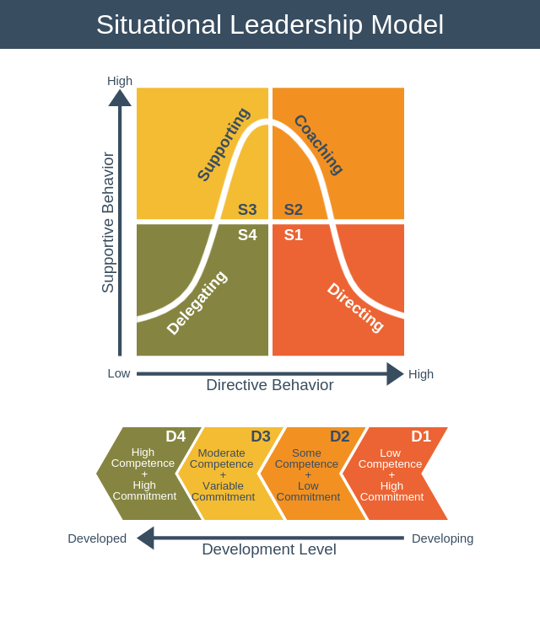
优点
- 解决了之前的理论的问题，相互影响
- 给领导人一些guideline
缺点
- 群众的situaition没有被很好的define，而且如何衡量两个量在这个理论里对于development占的比重没有被很好的说明
2．Leaders need to change quite immediately to the change in situation, the flexibility might bring inefficacy to task-oriented based leader where many routine, concept and regulation are inflexible

Contingency theory strengths
- It offers practical guidelines and tools that help leaders assess and adopt their leadership styles to meet subordinate’ needs.

- It creases attention on leaders’ impact on followers.

- They have been used regularly in training programmed for future leaders.

Weaknesses in contingency theories
-The early contingency theories reviewed are complex and difficult to test and the result are difficult to interpret.

-Most of the theories have conceptual weaknesses such as over-emphasis on broadly-defined behaviors, exclusion of relevant situational variables, and unclear explanation of causal relation and mediating processes.

- Most contingency theories do not consider how multiple situational variables interact in their moderating effects.

- Most contingency theories also fail to explain how leaders may improve work unit performance over a longer time period by reducing constraints and increasing substitutes.

- Most contingency theories explain only the separate, independent effects of each type of leadership behavior.

- Most contingency theories do not clearly indicate whether in the form of the relationship between independent variables and the dependent variables changes as the situational variable increases.

